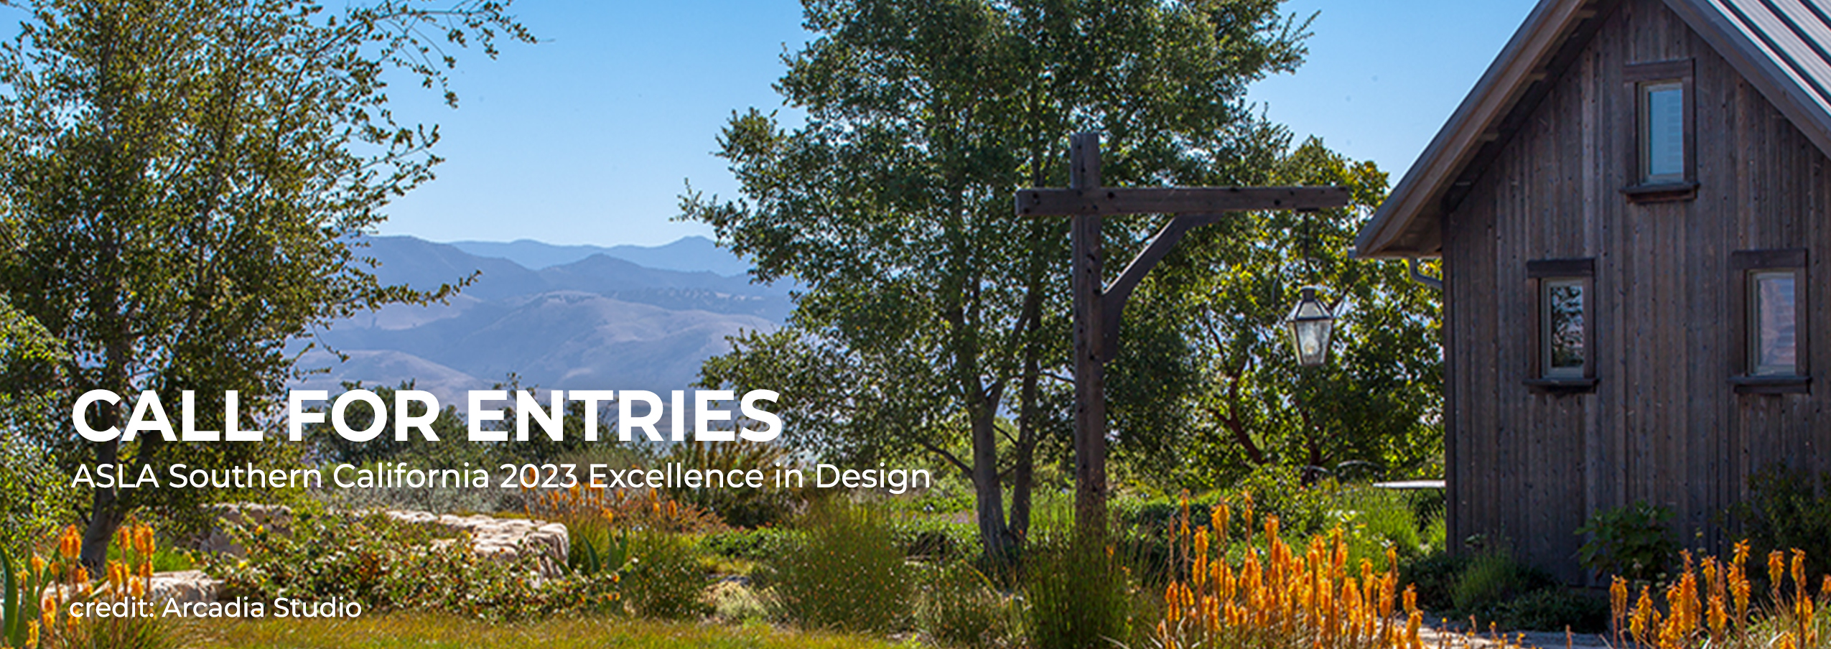

SOCAL ASLA 2023 QUALITY OF LIFE DESIGN AWARDS
CALL FOR ENTRIES

Entry Form – Provide all pertinent information along with a signed entry statement utilizing this entry form.

Name of Individual Submitting: ___________________________________________________________________

ASLA Membership Number: _________________ (you may reach out to ASLA or the local Chapter for your member #.)

The Southern California Chapter requires that individuals and/or firms submitting have a working, staffed and physical office in the Southern California Chapter including San Diego County.

Individual/Firm/Agency Name: ___________________________________________________________________

Business Address: _____________________________ City ______________ State _____________ Zip________

Office Phone: (_____) ___________________ Email Address: ___________________

Project Award Contact: ___________________________ Phone (______) ______________________

Include the following statement and signature as below: I certify that as the entrant, I am a Full Member, Full Fellow, or Associate member, in good standing with ASLA or otherwise meet the eligibility criteria as described on Page 1 of the Call for Entries and had primary involvement in the project entered. The submitted project was done in compliance with all licensure rules and regulations of the state in which it is located. I understand that all material submitted becomes the property of SOCAL ASLA and may be retained by SOCAL ASLA and used for the promotion of the profession.

Signature: __________________________________________ Date: ___________________________________

Project Name: ________________________________________________________________________________

Project Category (Residential, Commercial, etc.): ____________________________________________________

Name of Project Landscape Architect and Firm: _____________________________________________________
___________________________________________________________________________________________

Were other “landscape architecture firms” involved in this project? ____ yes ____no

If you answered yes to the question above, did you notify the other landscape architecture firm(s) you were going to submit the above-named project? ___yes ___no

Please list other landscape architecture firms involved below:
- _____________________________ 2. _________________________________

The Southern California Chapter encompasses the southern portion of California, south of the thirty-seventh (37th) parallel, including the Counties of Kern, Los Angeles, Orange, Riverside, San Bernardino, San Luis Obispo, Santa Barbara, and Ventura.



ENTRY PAYMENT
ASLA Members: $175.00
Non-Members: $300.00
ASLA Students: $40.00

Submission Fee by Check:
Make checks payable to ASLA Southern California and mail to 360 E. 1st Street, #371, Tustin, CA. 92780

Submission Fee by Credit Card:
Credit Card Information
Card Type: o MasterCard o Visa o AMEX
Amount: $ _______________________________
Cardholder Name (as shown on card): _______________________________
Card Number: ________________________________
Expiration Date (mm/yy): ______________________ CVV: _________________

I, ________________________, authorize the ASLA Southern California Chapter to charge my credit card above for agreed upon purchases. I understand that my information will be saved to file for future transactions on my account.
______________________________________ ___________________________________
Customer Signature Date

